INTRODUCTION:

"Welcome to our food delivery platform, where taste meets convenience! We are Melbin, Raj, Kartik, and Shubham, the creative minds behind this seamless online culinary experience.

Through our collective expertise in HTML and CSS, we've crafted a user-friendly interface that beckons with its simplicity yet delights with its functionality. With a blend of HTML's structural prowess and CSS's styling finesse, we've curated a digital space that celebrates deliciousness in every pixel.

Our focus has been on more than just aesthetics; it's about delivering an immersive browsing experience. From the clean lines of HTML that define the framework to the artistic touch of CSS that brings flavours to life, every element has been meticulously designed to ensure your journey through our platform is both enjoyable and intuitive.

We understand the importance of a visually appealing design that not only captivates but also navigates effortlessly. That's why our use of HTML and CSS has been purposeful, allowing us to create a responsive, user-centric platform that adapts seamlessly to your device, ensuring accessibility and ease no matter where you are.

So, dive into our virtual culinary world, explore enticing menus, and embark on a delightful gastronomic journey with just a click—all made possible by the harmony of HTML and CSS. Your cravings await, and we're here to make your food delivery experience a flavorful adventure!"

Technologies used:

The successful development of the Food Delivery Website ‘s frontend relied on a meticulous selection and utilization of cutting-edge web technologies. The integration of HTML and CSS formed the bedrock of our project, empowering us to create a robust, visually appealing, and interactive user interface.

**HTML5 - Structuring Content**

HTML5, as the core markup language, provided the structural foundation for the website. Leveraging its advanced features, we ensured semantic structuring and accessibility compliance, thereby enhancing the website's overall usability. Its elements facilitated a well-organized representation of content, optimizing search engine indexing and improving user navigation.

**CSS - Design and Styling**

Cascading Style Sheets (CSS) were instrumental in elevating the visual appeal of the website. Through CSS, we meticulously designed and stylized the interface, ensuring consistency, responsiveness, and aesthetic coherence across various devices and screen sizes. The use of CSS frameworks and methodologies streamlined our styling process, enabling efficient management and scalability of stylesheets.

Modules:

## Navigation Bar:-

Functionality:

**Header Structure:** The header layout comprises three sections: logo, search bar, and icons for essential functionalities (e.g., user profile, cart).

**Responsive Design:** The CSS incorporates a media query to make the navigation bar responsive for smaller screens. It adjusts the layout, sizes, and positions of elements to improve usability on mobile devices.

Interactive Icons: Icons change color and scale when hovered over, providing visual feedback to users.

Usefulness for an Food Delivery Website:

1. **Header Section (nav):**
   * Logo: Displaying the brand name "Healthy Habitats" with an image.
   * Navigation Menu: Links to various sections of the webpage like Home, About, Menu, Gallery, Healthy Tips, Contact Us, Signup, and Login.
2. **Home Section (section#home):**
   * Welcoming message and a call-to-action button for ordering food.
3. **Menu Section (section#our-menu):**
   * Divided into subsections for Veg Starters, Non-Veg Starters, Veg Dishes, Non-Veg Dishes, Beverages, and Desserts.
   * Each subsection contains an image, a title, and a list of food items with their respective prices.
4. **Gallery Section (section#gallery):**
   * Displays a collection of images showcasing the food or restaurant ambiance.
5. **Healthy Tips Section (section#health tips):**
   * Initially commented out, but appears to contain tips for healthy eating, with sections on health images and tips.
6. **Contact Section (section#contact):**
   * Contains a form for users to input their name, email, phone number, and message for feedback or suggestions.
7. **Footer:**
   * Displays copyright information and contact details including phone, email, opening hours, and address.

Functionality:

1. **Product Display:** The pro-container displays multiple pro elements, each containing an image, product details (brand, name, rating), price, and a shopping cart icon for adding items to the cart.
2. **Responsive Design:** The use of flex and min-width ensures that the products adapt to different screen sizes, allowing for a responsive layout on various devices.
3. **Hover Effects:** On hover, the products display a subtle box-shadow effect, providing a visual cue to users that these items are clickable or selectable.
4. **Clickable Shopping Cart Icon:** The shopping cart icon (fa fa-shopping-cart) serves as a call-to-action button allowing users to quickly add products to their carts.
5. **Styling for Product Details:** The CSS stylings (des) for product details like brand, name, rating, and price enhance readability and visual appeal.
6. **Positioning and Transition Effects**: The use of positioning properties (position: relative/absolute) and transitions (transition: 0.2s ease) create smooth visual effects and improve the overall aesthetics of the section.

Overall:

1. **Attracting User Attention:** The design of the webpage, including visuals, layout, and navigation, plays a significant role in attracting users. High-quality images of food items, well-structured menus, and an appealing layout immediately capture attention, enticing users to explore further.
2. **Essential Product Information:** Providing detailed and organized information about the products (in this case, food items) is crucial. The way the menu is presented—divided into categories, accompanied by clear descriptions and prices—helps users understand what's offered, fostering trust and aiding in decision-making.
3. **Encouraging Interaction:** Interactive elements like the order button, navigation links, and the contact form encourage users to engage with the website. The call-to-action prompts users to place orders, while the contact form facilitates communication, feedback, and potential customer inquiries.
4. **User Experience (UX):** A well-designed UX, achieved through the layout, ease of navigation, and responsiveness across devices, significantly impacts user satisfaction. Easy access to information, intuitive navigation, and a visually appealing interface enhance the overall experience, making users more likely to return
5. **Brand Image and Trust:** A professional, visually appealing design coupled with organized content helps establish a positive brand image. When users find a website easy to navigate and filled with relevant, accurate information, it builds trust and credibility, which is crucial in the competitive food delivery market.

In summary, the design, layout, and functionality of a food delivery webpage are not only about aesthetics but also about functionality, usability, and trust-building elements. They collectively contribute to engaging users, providing information, encouraging interaction, and ultimately driving conversions and sales.

### Banner Section (<section id="home">)

* **Functionality:**
  + **Visual Impact:** It's the first thing users see, presenting the brand name and a bold message, instantly capturing attention.
  + **Call-to-Action (CTA):** The "Order Now" button encourages immediate interaction, guiding users towards the primary action—placing an order.
  + **Branding:** The banner sets the tone and image of the brand through visuals and messaging.
* **Importance:**
  + **First Impression:** Establishes the website's tone and purpose, leaving a strong initial impression on visitors.
  + **Engagement:** Prompts users to take action, potentially leading to immediate conversions.
  + **Brand Recall:** Reinforces the brand name and message, aiding in user retention and recall.

### Menu Section (<section id="our-menu">)

* **Functionality:**
  + **Categorization:** Divides food items into categories (Veg Starters, Non-Veg Starters, etc.) for easy navigation and understanding.
  + **Detailed Presentation:** Lists items with prices, providing crucial information to users.
  + **Visual Representation:** Incorporates images to enhance the visual appeal of food items.
* **Importance:**
  + **Decision-making Support:** Assists users in selecting items by showcasing a range of choices and pricing.
  + **User Guidance:** Simplifies navigation through categorized content, reducing user effort in finding desired items.
  + **Sales Booster:** Attracts users and influences purchase decisions by presenting visually appealing and detailed menu options.

### Footer Section (<footer>)

* **Functionality:**
  + **Contact Information:** Provides crucial contact details, including phone number, email, and physical address, for users to reach the business.
  + **Legal & Business Details:** Contains copyright information and business operation hours.
  + **Website Navigation:** May include quick links or additional navigation for specific website sections.
* **Importance:**
  + **Trust & Credibility:** Contact details and business hours establish trust and credibility, reassuring users about the legitimacy of the business.
  + **Accessibility:** Provides easy access to essential information and contact details, enhancing user experience.
  + **Legal Compliance:** Includes necessary legal and ownership details, ensuring compliance and professionalism.

Each section fulfills a vital role in engaging users, providing essential information, and driving conversions. The banner creates the initial impact, the menu section aids in decision-making, and the footer ensures credibility and accessibility. Together, they form a cohesive user experience, crucial for success in the competitive food delivery market.

Website Screenshots and Code:

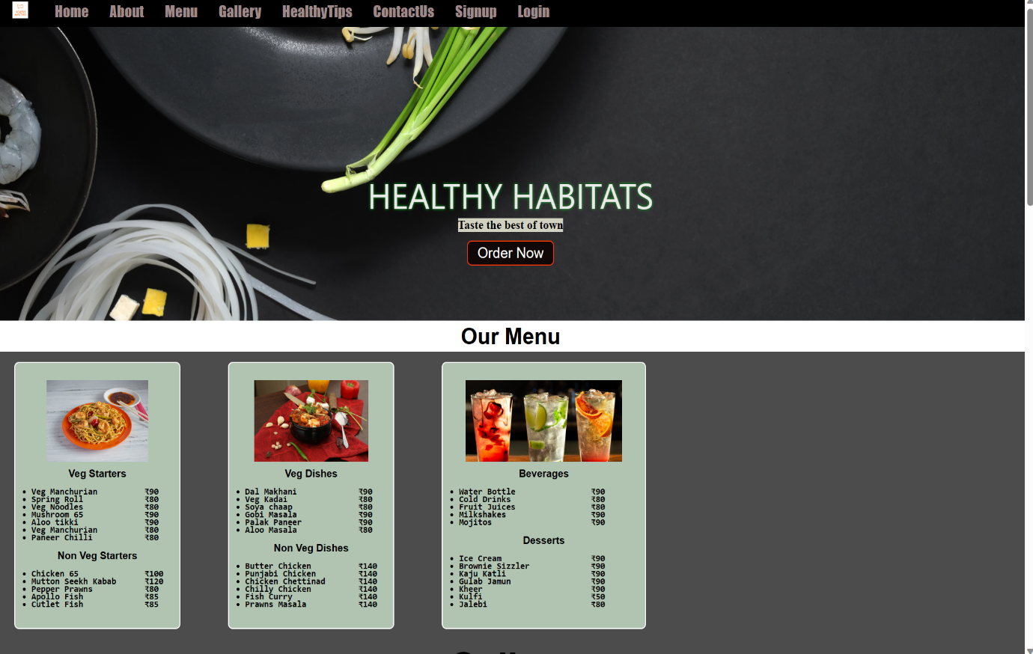

<nav id="navbar">

        <div id="logo">

                <img src='hh.png' alt="HEALTHY HABITATS" height='1000' weight='1000'>

            </div>

            <ul class="none">

            <li><a href="#home">Home</a> </li>

            <li><a href="about.html" target="_blank">About</a></li>

            <li><a href="#our-menu">Menu</a></li>

            <li><a href="#gallery">Gallery</a> </li>

            <li><a href='health tips.html'>HealthyTips</a> </li>

            <li><a href="#contact">ContactUs</a> </li>

            <li> <a href="pp.html">Signup</a></li>

            <li><a href="login.html">Login</a></li>

        </ul>

    </nav>

    <section id="home">

        <p>HEALTHY HABITATS</p>

        <h2>Taste the best of town</h2>

        <button class="btn">Order Now</button>

    </section>

    <section id="our-menu">

        <h1 class="h-primary center">Our Menu</h1>

        <div id="menu">

            <div class="box">

                <img src="img/1.jpg" alt="">

                <h2 class="h-secondary center">Veg Starters</h2>

                <div>

                    <ul>

                        <pre><b>

                            <li>Veg Manchurian          ₹90</li>

                            <li>Spring Roll             ₹80</li>

                            <li>Veg Noodles             ₹80</li>

                            <li>Mushroom 65             ₹90</li>

                            <li>Aloo tikki              ₹90</li>

                            <li>Veg Manchurian          ₹80</li>

                            <li>Paneer Chilli           ₹80</li></b>

                        </pre>

                        <h2 class="h-secondary center">Non Veg Starters</h2>

                        <pre>

                            <b>

                            <li>Chicken 65              ₹100</li>

                            <li>Mutton Seekh Kabab      ₹120</li>

                            <li>Pepper Prawns           ₹80</li>

                            <li>Apollo Fish             ₹85</li>

                            <li>Cutlet Fish             ₹85</li></b>

                        </pre>

                    </ul>

                </div>

            </div>

            <div class="box">

                <img src="img/2.jpg" alt="">

                <h2 class="h-secondary center">Veg Dishes</h2>

                <div>

                    <ul>

                        <pre>

                            <b>

                            <li>Dal Makhani             ₹90</li>

                            <li>Veg Kadai               ₹80</li>

                            <li>Soya chaap              ₹80</li>

                            <li>Gobi Masala             ₹90</li>

                            <li>Palak Paneer            ₹90</li>

                            <li>Aloo Masala             ₹80</li></b>

                        </pre>

                        <h2 class="h-secondary center">Non Veg Dishes</h2>

                        <pre>

                            <b>

                            <li>Butter Chicken          ₹140</li>

                            <li>Punjabi Chicken         ₹140</li>

                            <li>Chicken Chettinad       ₹140</li>

                            <li>Chilly Chicken          ₹140</li>

                            <li>Fish Curry              ₹140</li>

                            <li>Prawns Masala           ₹140</li></b>

                        </pre>

                    </ul>

                </div>

            </div>

            <div class="box">

                <img src='beverage.jpg' alt="">

                <h2 class="h-secondary center">Beverages</h2>

                <div>

                    <ul>

                        <pre><b>

                            <li>Water Bottle                ₹90</li>

                            <li>Cold Drinks                 ₹80</li>

                            <li>Fruit Juices                ₹80</li>

                            <li>Milkshakes                  ₹90</li>

                            <li>Mojitos                     ₹90</li></b>

                        </pre>

                        <h2 class="h-secondary center">Desserts</h2>

                        <pre>

                                    <b>

                                    <li>Ice Cream                   ₹90</li>

                                    <li>Brownie Sizzler             ₹90</li>

                                    <li>Kaju Katli                  ₹90</li>

                                    <li>Gulab Jamun                 ₹90</li>

                                    <li>Kheer                       ₹90</li>

                                    <li>Kulfi                       ₹50</li>

                                    <li>Jalebi                      ₹80</li></b>

                                </pre>

                    </ul>

                </div>

            </div>

        </div>

    </section>

 <section id="gallery">

        <h1 class="h3-primary center">Gallery</h1>

        <div class="grid-container">

            <div class="grid-item"><img class="images" src="img/gallery 1.jpg" alt="Gallery"></div>

            <div class="grid-item"><img class="images" src="img/gallery 2.jpg" alt="Gallery"></div>

            <div class="grid-item"><img class="images" src="img/gallery 3.jpg" alt="Gallery"></div>

            <div class="grid-item"><img class="images" src="img/gallery 4.jpg" alt="Gallery"></div>

            <div><img class="gallery1 zoom" src='tasty.webp'></div>

            <div class="grid-item"><img class="images" src="img/gallery 9.jpg" alt="Gallery"></div>

            <div class="grid-item"><img class="images" src="img/gallery 7.jpg" alt="Gallery"></div>

            <div class="grid-item"><img class="images" src="img/gallery 8.jpg" alt="Gallery"></div>

            <div class="grid-item"><img class="images" src="img/bn2.jpg" alt="Gallery"></div>

        </div>

    </section>

    <section id="health tips">

        <h1 class="h-primary center">Healthy Tips</h1>

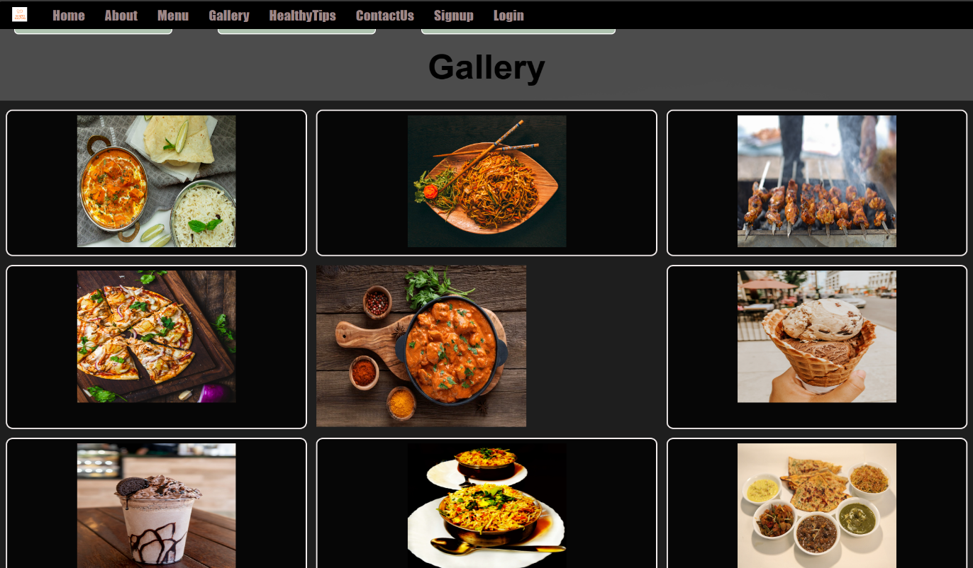

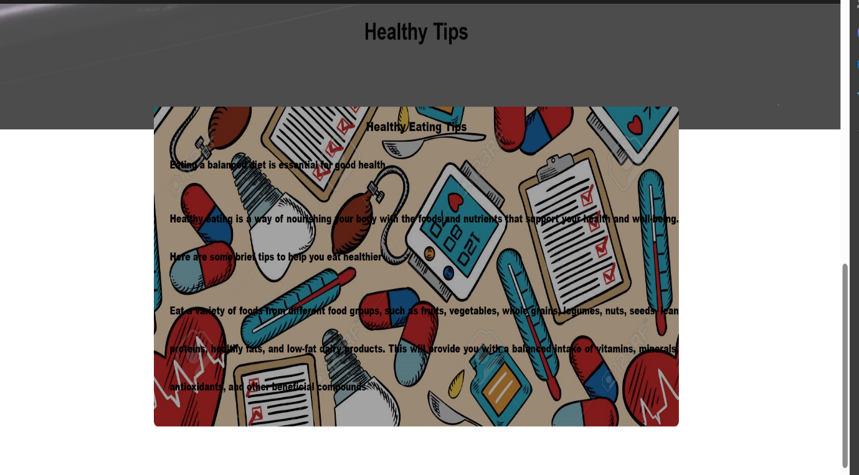

  <section id="health tips">

        <h1 class="h-primary center">Healthy Tips</h1>

                <div class="container">

                    <h1>Healthy Eating Tips</h1>

                    <b><p>Eating a balanced diet is essential for good health...</p>

                    <p>Healthy eating is a way of nourishing your body with the foods and nutrients that support your health and well-being. Here are some brief tips to help you eat healthier</p>

                      <p>Eat a variety of foods from different food groups, such as fruits, vegetables, whole grains, legumes, nuts, seeds, lean proteins, healthy fats, and low-fat dairy products. This will provide you with a balanced intake of vitamins, minerals, antioxidants, and other beneficial compounds</p></b>

                  </div>

            </div>

        </div>

        </div>

    </section>

    <section id="contact">

        <h1 class="h-primary center">Contact Us</h1>

        <div id="contact-box">

            <form action="">

                <div class="form-group">

                    <label for="name">Name: </label>

                    <input type="text" name="name" id="name" placeholder="Enter your name">

                </div>

                <div class="form-group">

                    <label for="email">Email: </label>

                    <input type="email" name="name" id="email" placeholder="Enter your email">

                </div>

                <div class="form-group">

                    <label for="phone">Phone Number: </label>

                    <input type="number" name="name" id="phone" placeholder="Enter your phone">

                </div>

                <div class="form-group">

                    <label for="message">Feedback/Suggestions/Any Messages: </label>

                    <textarea name="message" id="message" cols="30" rows="10"></textarea>

                </div>

                <div>

                    <input type="submit" value="Submit Now">

                    <input type="reset" value="Reset Now">

                </div>

            </form>

        </div>

    </section>

    <footer>

        <div class="center">

            Copyright &copy;<a href="www.healthy habitats.com">www.healthy habitats.com</a>. All rights reserved!

        </div>

        <div>

            <li

                style="font-size: 15px; color: rgba(255, 255, 255); text-align:justify; margin-left: 285px; display: flex;">

                Phone: 6201169XXX <br> Email: support@healthy habitats.in <br> Opening Hours: 8am - 11pm <br> Address:

                G-50,Sector 18,Phaghwara, Jalandhar 201301,</li>

        </div>

    </footer>